Analisis Tipologi Kutipan

Tema 1: Revival Memory - Representasi Trend Y2K dalam Media Online
Tabel 1: Kutipan Verbatim - Revival Memory
No | Nama Media | Tanggal | Kutipan Verbatim
1 | Harper's Bazar | 19 Juli 2025 | For her Lollapalooza Paris performance, Rodrigo continued her streak of blending edgy rock aesthetics with soft, feminine, Y2K-inspired pieces.  She wore a nostalgic chainmail halter top adorned with alternating silver and black stripes. The cropped piece featured an asymmetrical hemline with fringe details.
2 | teen VOGUE | 2025-09-23 00:00:00 | The Ara Top, which everyone online seems to be obsessed with, also features a built-in scarf detail, flutter sleeves, and, to add to the peekaboo effect, a keyhole center that extends to the bodice with button-up detailing. Less is, indeed, more — at least when it comes to the fabric construction of these pieces.  If you thought Rodrigo's homage to the '00s ended with her jeans, think again. The star also added a thick silver bangle, another Y2K staple, as well as just a hint of leopard print with her $258 Kate Spade bag. Talk about a perfect modern-yet-nostalgic combo!
3 | AOL | 19 Juli 2025 | "Hearst Magazines and Yahoo may earn commission or revenue on some items through these links."  Music festival season is still in full swing, and Olivia Rodrigo is having the time of her life.  Fresh off headlining Glastonbury in England—where she surprised fans by bringing out Robert Smith of The Cure to perform “Friday I’m in Love” and “Just Like Heaven”—the singer has returned to the stage, this time jetting off to the City of Light to headline another major event.  For her Lollapalooza Paris performance, Rodrigo continued her streak of blending edgy rock aesthetics with soft, feminine, Y2K-inspired pieces.  She wore a nostalgic chainmail halter top adorned with alternating silver and black stripes. The cropped piece featured an asymmetrical hemline with fringe details.
4 | Marie Claire | 2024-11-16 00:00:00 | Olivia Rodrigo doesn't mind one bit if you can see her underwear. In fact, that was kind of the point of her outfit at the Billboard Live Music Summit in Los Angeles on Thursday. Before collecting her award for touring artist of the year, the pop star pulled up to the 1 Hotel in West Hollywood wearing a pitch-perfect Y2K look packed with covetable vintage designer finds.
5 | Near | 26 Februari 2025 | Affinity for Nostalgia  If you’re a millennial who has felt a connection to Olivia Rodrigo’s music because of how much it reminds you of what you listened to growing up, then you’re not alone. The Fil-Am musician draws influences from the likes of millennial favorites Paramore and Taylor Swift, whom she even gave songwriting creds on her hits “good 4 u” and “deja vu,” respectively.  And Olivia Rodrigo isn’t the only one riding the nostalgia wave. Generation Z is leading the trend, whether it be in the music they gravitate towards or their fashion preferences. There is a collective longing for simpler times that’s so specific to Gen Z because they are growing up in a time of rapid, chaotic change in the world, so they love things that capture a sense of nostalgia.
6 | Yahoo Entertainment | 25 Mei 2024 | Le Specs Work It Sunglasses  Rodrigo has become synonymous with nostalgic dressing, especially when it comes to '90s and early 2000s fashion—and her wardrobe on the GUTS tour, for the most part, has been no different. So far, Rodrigo has dominated the stage in cheeky, customized emblazoned tanks and visible bra straps.  The "vampire" singer enjoys more laid-back casual looks when she's not on the clock. For her daytime street-style appearances, she usually wears her favorite wardrobe staples, such as cozy knits, combat boots, and vintage bags. While Rodrigo's white dress is a subtle departure away from her usual styles, the musician keeps a few go-to frocks in her closet rotation, her favorites often hailing from brands like Reformation.
7 | Yahoo Entertainment | 25 Mei 2024 | Le Specs Work It Sunglasses  Rodrigo has become synonymous with nostalgic dressing, especially when it comes to '90s and early 2000s fashion—and her wardrobe on the GUTS tour, for the most part, has been no different. So far, Rodrigo has dominated the stage in cheeky, customized emblazoned tanks and visible bra straps.  The "vampire" singer enjoys more laid-back casual looks when she's not on the clock. For her daytime street-style appearances, she usually wears her favorite wardrobe staples, such as cozy knits, combat boots, and vintage bags. While Rodrigo's white dress is a subtle departure away from her usual styles, the musician keeps a few go-to frocks in her closet rotation, her favorites often hailing from brands like Reformation.
8 | Yahoo Entertainment | 2024-11-16 00:00:00 | Olivia Rodrigo doesn't mind one bit if you can see her underwear. In fact, that was kind of the point of her outfit at the Billboard Live Music Summit in Los Angeles on Thursday. Before collecting her award for touring artist of the year, the pop star pulled up to the 1 Hotel in West Hollywood wearing a pitch-perfect Y2K look packed with covetable vintage designer finds.
9 | Yahoo Life | 2024-04-11 00:00:00 | Low-waisted pants have been a huge trend recently, so long shirts were also overdue for a comeback. And with the belt worn over her shirt, Kaia’s look is very Y2K-coded. Although the model usually wears ’90s-inspired staples, she managed to make these risky 2000s trends look chic. And her Olivia Rodrigo concert outfit has managed to make us seriously nostalgic for noughties fashion (in a good way). Kaia’s eclipse-viewing outfit is a classic example of her classic style. Her kitten heels, midi skirt, and long sleeve crop top could’ve very well walked out of a 90s romcom. Leave it to her to look so effortlessly stylish while wearing eclipse glasses.
10 | New York Times | 25 Oktober 2025 | But I’m not trying to nostalgia farm and wax poetic, I swear. Nor am I here to defend, dissect or take down the toxic dynamics inherent to the nu metal scene. The lyrics were often obscene and nihilistic, and the energy frequently tipped toward anarchy. As a young woman enmeshed in the dude-heavy environment, you don’t need to tell me. We can also probably agree that most Y2K pop culture touchstones had a very dark side.  This instead is an ode to a realization that those of us who came of age in that moment were the last wave of disaffected youth to have something we didn’t even know we had, something we were all about to lose: the ability to express ourselves freely in public without the ever-looming specter of perpetual surveillance, digital documentation and social-media receipts. When we raged, we never considered that we were being watched, because we weren’t.
11 | Medium | 14 Desember 2024 | Cycle Accelerator 1: The COVID-19 Pandemic  The COVID-19 pandemic played a significant role in accelerating the return of 2000s trends, as many people sought comfort in nostalgia during a time of uncertainty and isolation. With in-person social interaction on hold, individuals retreated to old hobbies and comforting childhood memories. This cultural revival was driven not only by a desire for familiarity but also by the digital age’s ability to instantly bring trends back to life, making them more accessible and relatable to younger generations who never got the chance to experience them firsthand. As a result, the 2000s aesthetic became a symbol of comfort, escapism, and self-expression amid the chaos of the pandemic.
12 | The Science Survey | 10 Juli 2024 | With 1.56 billion users worldwide, 148.92 million of them from the United States as of 2024, TikTok’s social influence has played a significant role in reviving nostalgia for iconic styles of the past. Through its viral challenges and diverse user base, TikTok has become a hub for community and shared experiences, making it easier for trends from previous decades to resurface and gain popularity among younger generations.  When asked how TikTok has influenced their life, Ruby Moran ’24 said, “I ended up being influenced by it in a way similar to how one would be influenced by the group of friends they surround themselves with. I said I hated pink, I said I hated dresses, and I refused to learn how to do makeup mainly because of the commentary typically thrown around that made more feminine women seem weaker or somehow incompetent in a way. But seeing other women being themselves, choosing to be as feminine or as masculine as they wanted, motivated me to do the same. It turns out pink is one of my favorite colors, it turns out that I want to explore different styles of clothing, including dresses and skirts, and it turns out that I’m actually really curious about makeup and would love to learn more about it.”
13 | Palmetto & Pine | 7 Oktober 2025 | Music is also part of the comeback. While early singing icons like Destiny’s Child, Britney Spears, and NSYNC are still loved dearly, newer artists like Olivia Rodrigo and Doja Cat feature Y2K inspired sounds in their songs on recent albums. The popularity of these artists showcases the growing popularity for all things Y2K. This revival reflects more than just fashion, diving deeper into a cultural nostalgia. In 2025, Y2K’s boldness and colorful aspect serve as a reminder of a time that felt bubbly and lighter, embracing fun.  Beyond the fashion and music industry, entertainment is also leaning into the throwback. The recent movie sequel of Freaky Friday, Freakier Friday, reignited love for the 2003 classic, drawing in both nostalgic millennials and introducing itself to new curious Gen Z viewers. This wave of revivals in the film industry shows how studios are ready to re-introduce old classics into today’s cultural spotlight, banking on both nostalgia and new, interested viewers. Through updating familiar plots in a modern way, it gets pushed to both new crowds and those still seeking nostalgia. The result is an important experience that keeps 2000s media alive, while updating it to fit the new generation’s expectations, based on streaming services, and social media.
14 | Palmetto & Pine | 7 Oktober 2025 | Chunky sneakers, cropped tops, and shiny accessories are so back. Across the city of St. Petersburg, and beyond, Gen Z is reviving Y2K fashion and culture– proving that the 2000s are back and trending. The Y2K era, mostly known for its flashy fashion and futuristic designs, is having a major revival in 2025. Many are wondering, why is this style from decades ago suddenly reappearing?  Part of the answer comes from TikTok, where thrift hauls, outfit inspos, and short videos of 2000s memorabilia are getting an uprise in views. Brands like Hollister are trying to revive their fan-adored 2000s collections with a new 25th-anniversary Y2K capsule collection. This includes signature styles like babydoll tops, ultra-low-rise shorts, and bootcut jeans. Locally, shops like Ingrid’s Vintage & Thrift Shop in St. Petersburg are preparing empty racks for the revival, offering affordable thrifted Y2K clothing alongside vinyls and decor. Online shopping has made it easier than ever for consumers to buy without hassle. Apps like Depop and Poshmark have fueled the revival of the 2000s fashion, connecting Gen Z directly to vintage resellers and a multitude of Y2K styles long since out of stock.
15 | Palmetto & Pine | 7 Oktober 2025 | Chunky sneakers, cropped tops, and shiny accessories are so back. Across the city of St. Petersburg, and beyond, Gen Z is reviving Y2K fashion and culture– proving that the 2000s are back and trending. The Y2K era, mostly known for its flashy fashion and futuristic designs, is having a major revival in 2025. Many are wondering, why is this style from decades ago suddenly reappearing?  Part of the answer comes from TikTok, where thrift hauls, outfit inspos, and short videos of 2000s memorabilia are getting an uprise in views. Brands like Hollister are trying to revive their fan-adored 2000s collections with a new 25th-anniversary Y2K capsule collection. This includes signature styles like babydoll tops, ultra-low-rise shorts, and bootcut jeans. Locally, shops like Ingrid’s Vintage & Thrift Shop in St. Petersburg are preparing empty racks for the revival, offering affordable thrifted Y2K clothing alongside vinyls and decor. Online shopping has made it easier than ever for consumers to buy without hassle. Apps like Depop and Poshmark have fueled the revival of the 2000s fashion, connecting Gen Z directly to vintage resellers and a multitude of Y2K styles long since out of stock.
16 | The Lamron | 2025-04-11 00:00:00 | Rodrigo’s pop career began with the release of her debut single, “Driver’s License,” when she was just 17 years old. Her first album, Sour (2021), was branded with “Y2K” nostalgia (glitter, stickers, purple, and butterfly clips), capturing teenage innocence, heartbreak, and angst. Reflected in her tour outfits, this style won the hearts of fans, but many pigeon-holed Rodrigo as the embodiment of this teenage-d innocence.  Now, in the South American leg of her Guts World Tour, 22-year-old Olivia Rodrigo is facing online backlash for her “new” dances and outfits in her performances. Commenters generally think the singer is “over-sexualizing herself,” “too angsty,” and “cringe.” In viral TikTok videos of her tour, many express that this new look does not suit her and that she is “not herself.”  I think every artist is susceptible to critique, but a part of me feels that if Olivia Rodrigo was introduced to the pop scene as a 22-year-old, rebellious, pop-rock performer, her new methods of performing would be easily digested by the media. This explicit performance style is trending right now, with artists like Charli xcx spitting on the floor during shows, yet it is those with the Disney Channel background, or who skyrocket to notoriety while young, who are held on different pedestals.
17 | Medium | 2025-09-25 00:00:00 | Fashion has always been cyclical, but few trends have made a comeback as powerful as Y2K. What began as a futuristic fantasy in the late 1990s has evolved into a cultural revival in the 2020s. The Y2K aesthetic has not only resurfaced it has transformed, reflecting shifting values, technology, and the rise of digital culture.
18 | Young Hollywood | 25 Mei 2025 | You head out the door, rocking low-rise jeans, a baby tee with a bold statement, a trucker hat, or a velour sweatsuit. Nonetheless, your outfit understood the assignment and earned extra credit! Your phone is glued to your hip, ready to bump the latest banger when a call comes in. Cue the nostalgia, it's the iconic 2000s era! But, wait a minute, this looks way too familiar again. It’s now 2025, and you can rock the same fit, same hair, makeup, and accessories, and you are still serving looks, with 10s across the board. This is because the Y2K era is revived, and this time, Gen-Z is adding its own spin on it, using the media as an influence.
19 | RTE | 2024-04-08 00:00:00 | Opinion: Nostalgia for early 2000s' pop and fashion may paint a rosy picture, but it ignores the complex and contradictory realities of that era  It's clear that nostalgia for the 2000s is significantly shaping major trends in contemporary culture, leaving a lasting impact on society as a whole. We've seen the revival of Y2K-inspired fashion trends, such as the return of low-rise jeans. You can also add in the remake of the 2000s cult classic, Mean Girls and the resurgence of the pop-punk music genre, exemplified by chart-topping albums like Guts by Olivia Rodrigo,  As nostalgia often does, such nostalgia brings us comfort as a psychological phenomenon, but there is a darker side to this nostalgia. This is something we often overlook, due to our failure to recognise problematic aspects of something at the time, or our tendency to forget them as they become distant memories.
20 | RTE | 2024-04-08 00:00:00 | Opinion: Nostalgia for early 2000s' pop and fashion may paint a rosy picture, but it ignores the complex and contradictory realities of that era  It's clear that nostalgia for the 2000s is significantly shaping major trends in contemporary culture, leaving a lasting impact on society as a whole. We've seen the revival of Y2K-inspired fashion trends, such as the return of low-rise jeans. You can also add in the remake of the 2000s cult classic, Mean Girls and the resurgence of the pop-punk music genre, exemplified by chart-topping albums like Guts by Olivia Rodrigo,  As nostalgia often does, such nostalgia brings us comfort as a psychological phenomenon, but there is a darker side to this nostalgia. This is something we often overlook, due to our failure to recognise problematic aspects of something at the time, or our tendency to forget them as they become distant memories.
21 | L'Officiel | 2024-04-17 00:00:00 | Nostalgia rules the fashion cycle but each generation is different; while Millennials hang onto '90s trends, Gen Z finds comfort in the not-too-distant styles of the early 2000s.
22 | Cosmopolitan | 9 Juni 2025 | As the temps start rising into a blistering summer heat and our speakers turn up a few decibels, that can only mean one thing: festival season is officially upon us. Whether you hit the grounds to discover new artists, try some next-level bites, or pull up in your best outfits, music festivals are the best place to hang out and build a community. All of the above were accomplished at New York City’s very own Governors Ball, as its return to Flushing Meadows Corona Park marked its 15th anniversary and gave us an extra reason to pull up and celebrate.  The festival felt like a perfectly curated soundtrack to our summer—with headliners like Tyler, the Creator; Olivia Rodrigo; and Hozier offering set after set of jaw-dropping energy. Even with weather delays smack in the middle of the festival, crowds formed for their fave artists, and every genre found its spotlight: T‑Pain brought on some Y2K nostalgia, Clairo serenaded festivalgoers in the soft rain, and indie’s rising star Mk.gee stole the hearts of newfound fans. Whether you were vibing through Benson Boone’s backflips or bouncing with The Beaches, the energy was seriously contagious.
23 | Pop Sugar | 10 Juni 2024 | Nothing stokes a wave of Y2K nostalgia quite like a trip down Olivia Rodrigo's discography, but it's her accompanying hairstyles that are the retro exclamation point. Baby bangs! Space buns! Colorful barrettes, butterfly clips, and other whimsical accoutrements! All evoke the early millennia, and all come courtesy of Clayton Hawkins, the star's longtime hairstylist.  My own aesthetic in the early aughts (and much to my parents' disdain) leaned more Avril Lavigne from "Sk8er Boi" — as in, heavy eyeliner, yes; so much as brushing my hair? No — so last place I expected to find myself was in Hawkins chair, kindly requesting the Olivia Rodrigo special from the man behind all her looks. When in Rome or whatever.
24 | Pop Sugar | 10 Juni 2024 | Nothing stokes a wave of Y2K nostalgia quite like a trip down Olivia Rodrigo's discography, but it's her accompanying hairstyles that are the retro exclamation point. Baby bangs! Space buns! Colorful barrettes, butterfly clips, and other whimsical accoutrements! All evoke the early millennia, and all come courtesy of Clayton Hawkins, the star's longtime hairstylist.  My own aesthetic in the early aughts (and much to my parents' disdain) leaned more Avril Lavigne from "Sk8er Boi" — as in, heavy eyeliner, yes; so much as brushing my hair? No — so last place I expected to find myself was in Hawkins chair, kindly requesting the Olivia Rodrigo special from the man behind all her looks. When in Rome or whatever.
25 | Yahoo Entertainment | 3 Februari 2025 | Olivia Rodrigo took the Y2K revival to another level at the Grammys 2025. The music star who attended the 67th installment of the awards show as a presenter wore a Versace gown that recalled a very specific moment in Grammys fashion history.
26 | Yahoo Life | 28 Mei 2024 | Sponsored content. Us Weekly receives compensation for this article as well as for purchases made when you click on a link and buy something below.  When it comes to the Y2K aesthetic, one sometimes overlooked facet of the look is the alt, clunky shoes of the time. Whether it was wedges or boots, the early aughts were known for their affinity to make the bulkiest shoes popular. Olivia Rodrigo, known for starring in High School Musical: The Musical: The Series and making chart-topping hits like drivers license and deja vu, has found her niche within this nostalgic way of dressing.
27 | Jumlah Kutipan yang presisi |  | 37
28 | Jumlah Kutipan yang presisi |  | 29
29 | Jumlah Kutipan yang presisi |  | 8
30 | Jumlah Kutipan yang presisi |  | 18

Tema 2: Identitas Gen Z - Figur Selebriti Olivia Rodrigo Dalam Trend Y2K
Tabel 2: Kutipan Verbatim - Identitas Gen Z
No | Nama Media | Tanggal | Kutipan Verbatim
1 | Prestige | 2024-11-21 00:00:00 | The Gen Z pop phenomenon Many Grammy Awards, a sold-out global tour, and singles like “Drivers License” that have broken many Spotify records are just a few of Olivia Rodrigo’s accomplishments. The 21-year-old’s star power also extends to the cosmetics industry, where her distinct grunge-inspired style has brought new trends into the fold and revitalized some timeless old ones. In terms of hair and makeup, the singer enjoys experimenting without going too far from her characteristic look, which is purple with dramatic red lips and a sharp cat eye. We showcase the distinctive and distinctive beauty trends ahead. Olivia Rodrigo: so thoughtful, yet so spoiled!  Like any other Gen Z, Olivia’s love for the ’90s is well-documented. Fishnet tights, butterfly accessories, slogan t-shirts that read “please don’t stay in touch”, all suggest her love for a period that existed before she was born. The singer draws on this Britney Spears-dominated era to create an aesthetic that straddles between grunge glamour and edgy minimalism. In doing so, Olivia Rodrigo has inspired cutesy beauty trends that are at odds with her songs of loss and heartbreak. Take a look at some of them below.
2 | The Orbit | 28 Maret 2025 | We've all heard it: Gen Z is the social media generation, the trendsetters, the ones shaking up the status quo. But, who would have thought, they're not all cut from the same cloth. Beneath the hype, Gen Z, like any other generation, is an incredibly diverse group with tastes, values and personalities. Labels aren’t really doing them justice.  Visualize walking into a bustling café. At one table, a group debates the pros and cons of various mental health apps, sharing tips on mindfulness and self-care. In the corner, someone is live-streaming a gaming session, while others are deep into a discussion about intersectional feminism.
3 | Palmetto & Pine | 7 Oktober 2025 | Chunky sneakers, cropped tops, and shiny accessories are so back. Across the city of St. Petersburg, and beyond, Gen Z is reviving Y2K fashion and culture– proving that the 2000s are back and trending. The Y2K era, mostly known for its flashy fashion and futuristic designs, is having a major revival in 2025. Many are wondering, why is this style from decades ago suddenly reappearing?  Part of the answer comes from TikTok, where thrift hauls, outfit inspos, and short videos of 2000s memorabilia are getting an uprise in views. Brands like Hollister are trying to revive their fan-adored 2000s collections with a new 25th-anniversary Y2K capsule collection. This includes signature styles like babydoll tops, ultra-low-rise shorts, and bootcut jeans. Locally, shops like Ingrid’s Vintage & Thrift Shop in St. Petersburg are preparing empty racks for the revival, offering affordable thrifted Y2K clothing alongside vinyls and decor. Online shopping has made it easier than ever for consumers to buy without hassle. Apps like Depop and Poshmark have fueled the revival of the 2000s fashion, connecting Gen Z directly to vintage resellers and a multitude of Y2K styles long since out of stock.
4 | L'Officiel | 2024-04-17 00:00:00 | Nostalgia rules the fashion cycle but each generation is different; while Millennials hang onto '90s trends, Gen Z finds comfort in the not-too-distant styles of the early 2000s.
5 | Jumlah Kutipan yang presisi |  | 38

Visualisasi Word Cloud
Word Cloud 1: Revival Memory
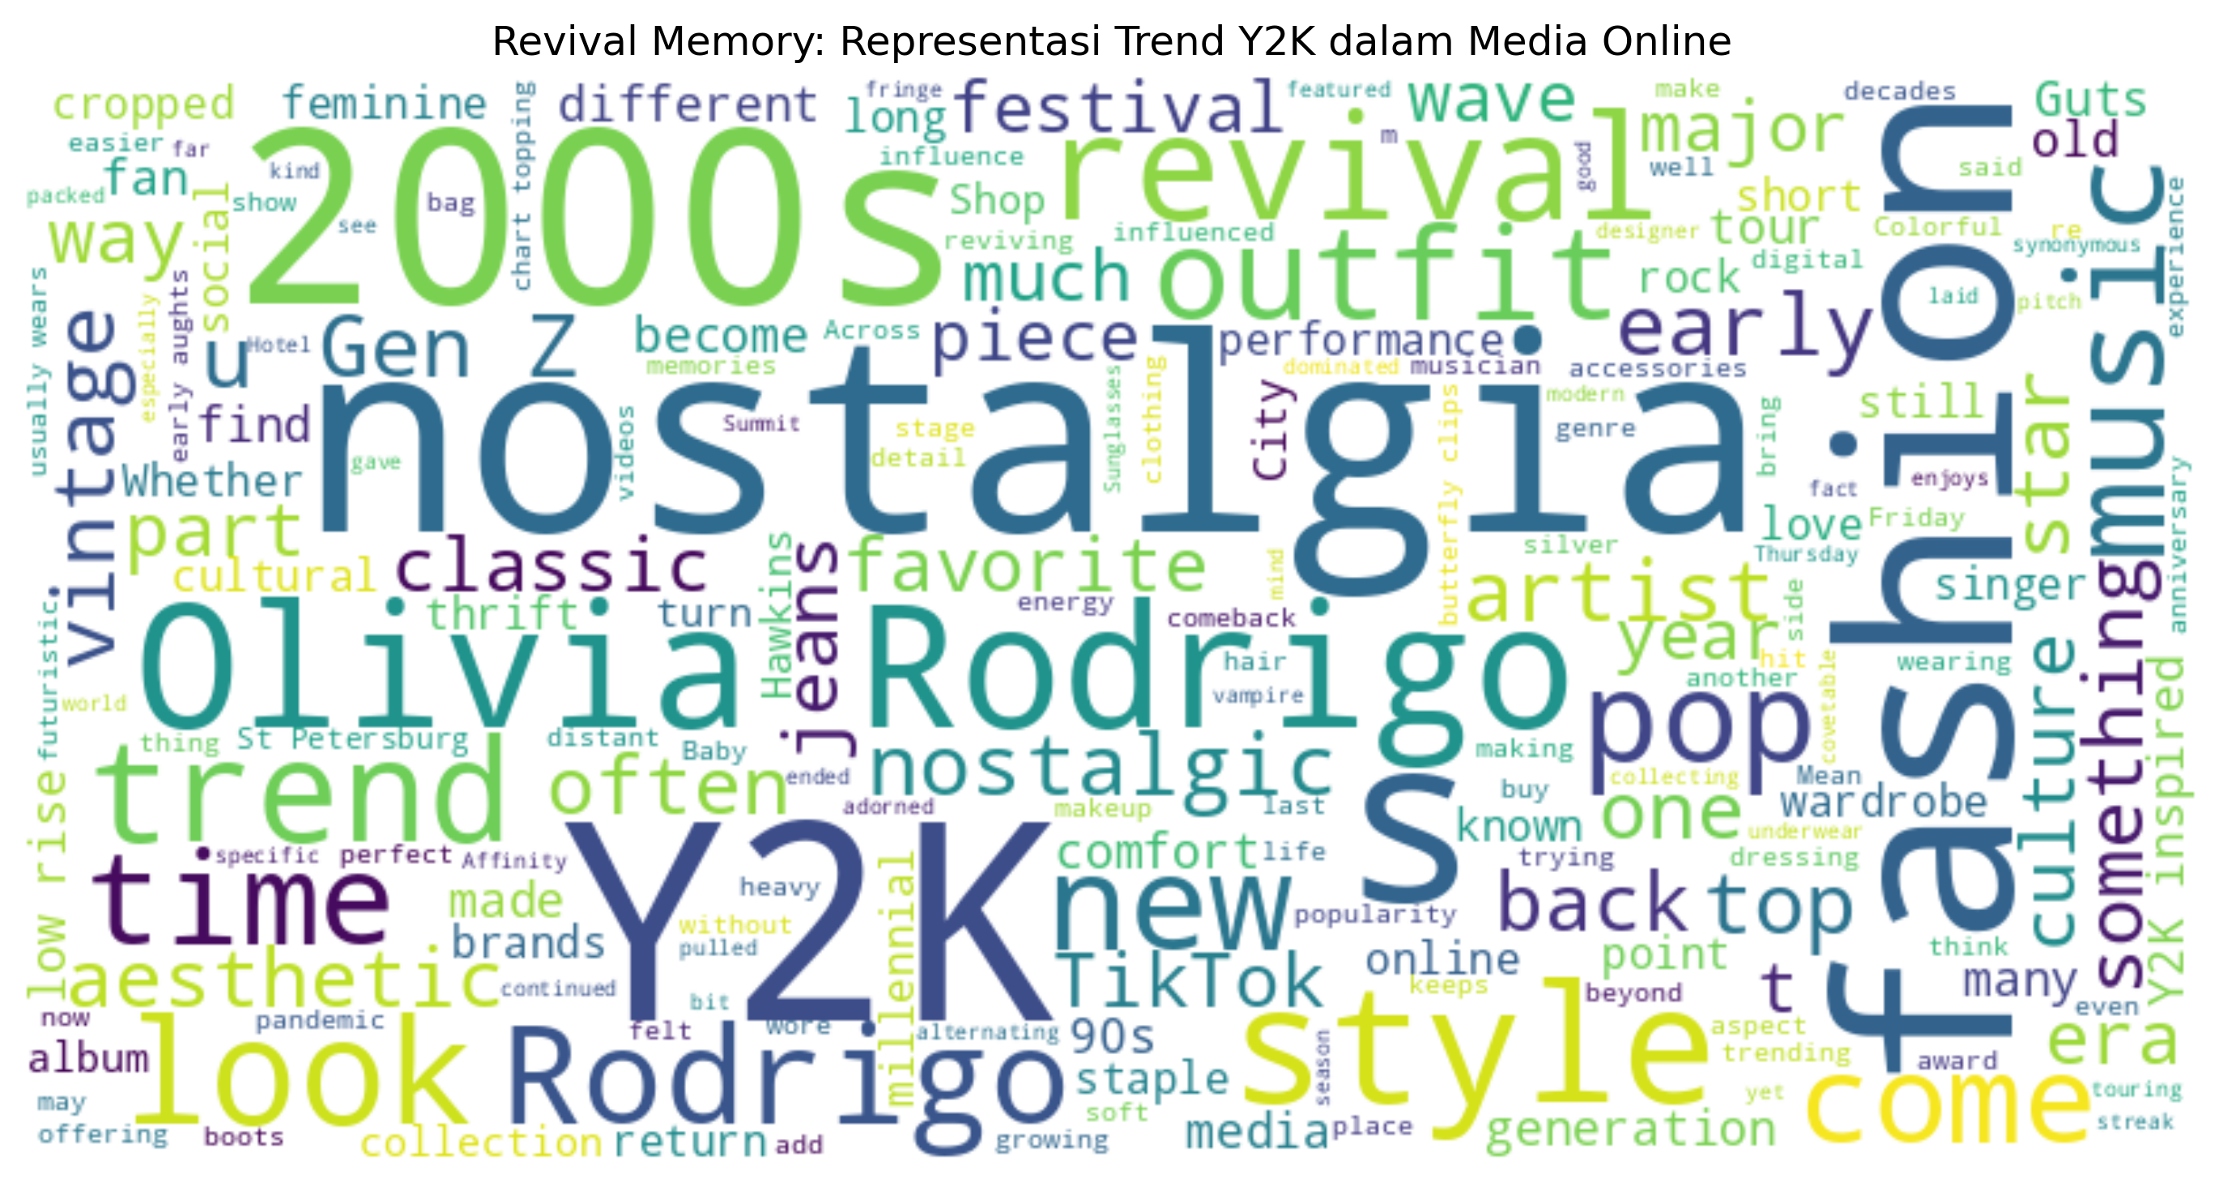
Word Cloud 2: Identitas Gen Z
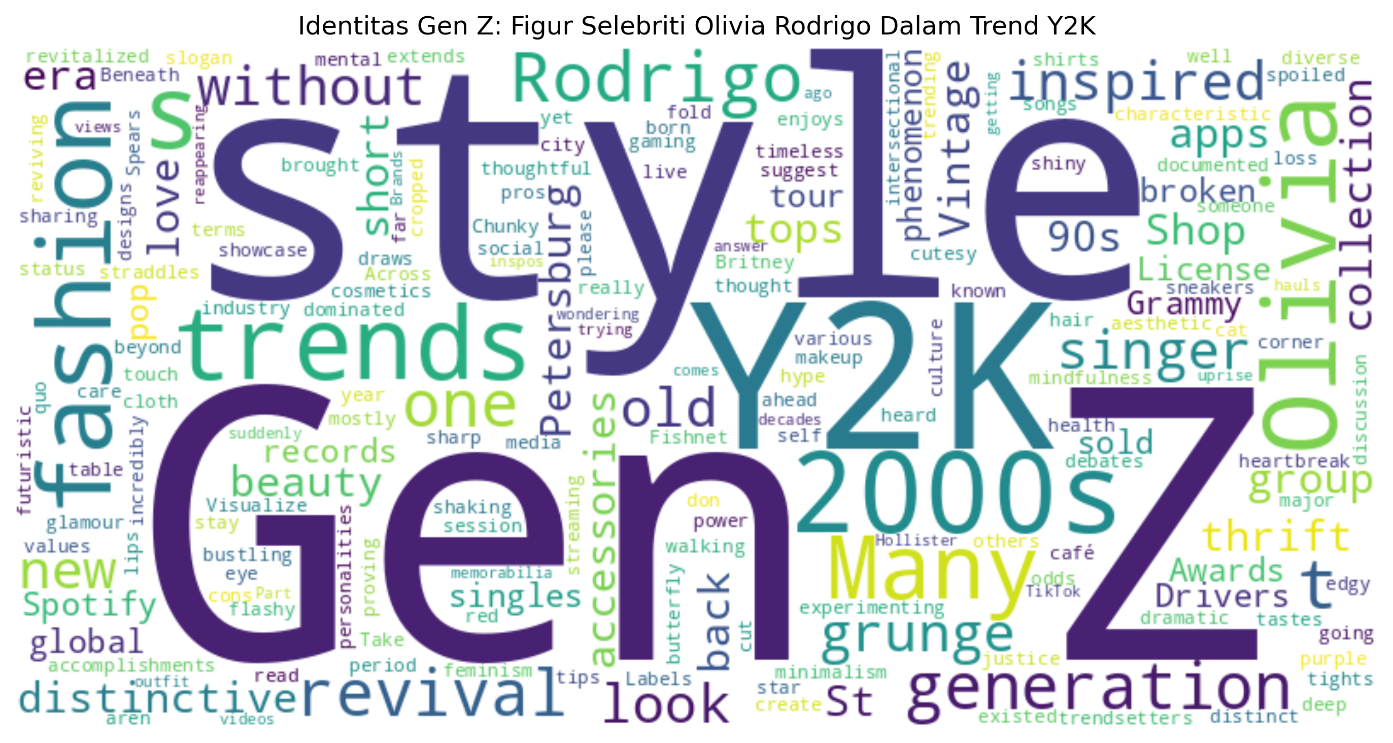

Kesimpulan
Ringkasan Analisis:
1. Tema Revival Memory (Nostalgic, Vintage, Retro, Revival):
- Total kutipan: 30
- Jumlah media: 18
2. Tema Identitas Gen Z:
- Total kutipan: 5
- Jumlah media: 5
3. Total keseluruhan:
- Total media unik yang dianalisis: 20
- Total kutipan: 35

